22nd International Seminar
„Track Maintenance Machines in Theory and Practice - SETRAS 2017“
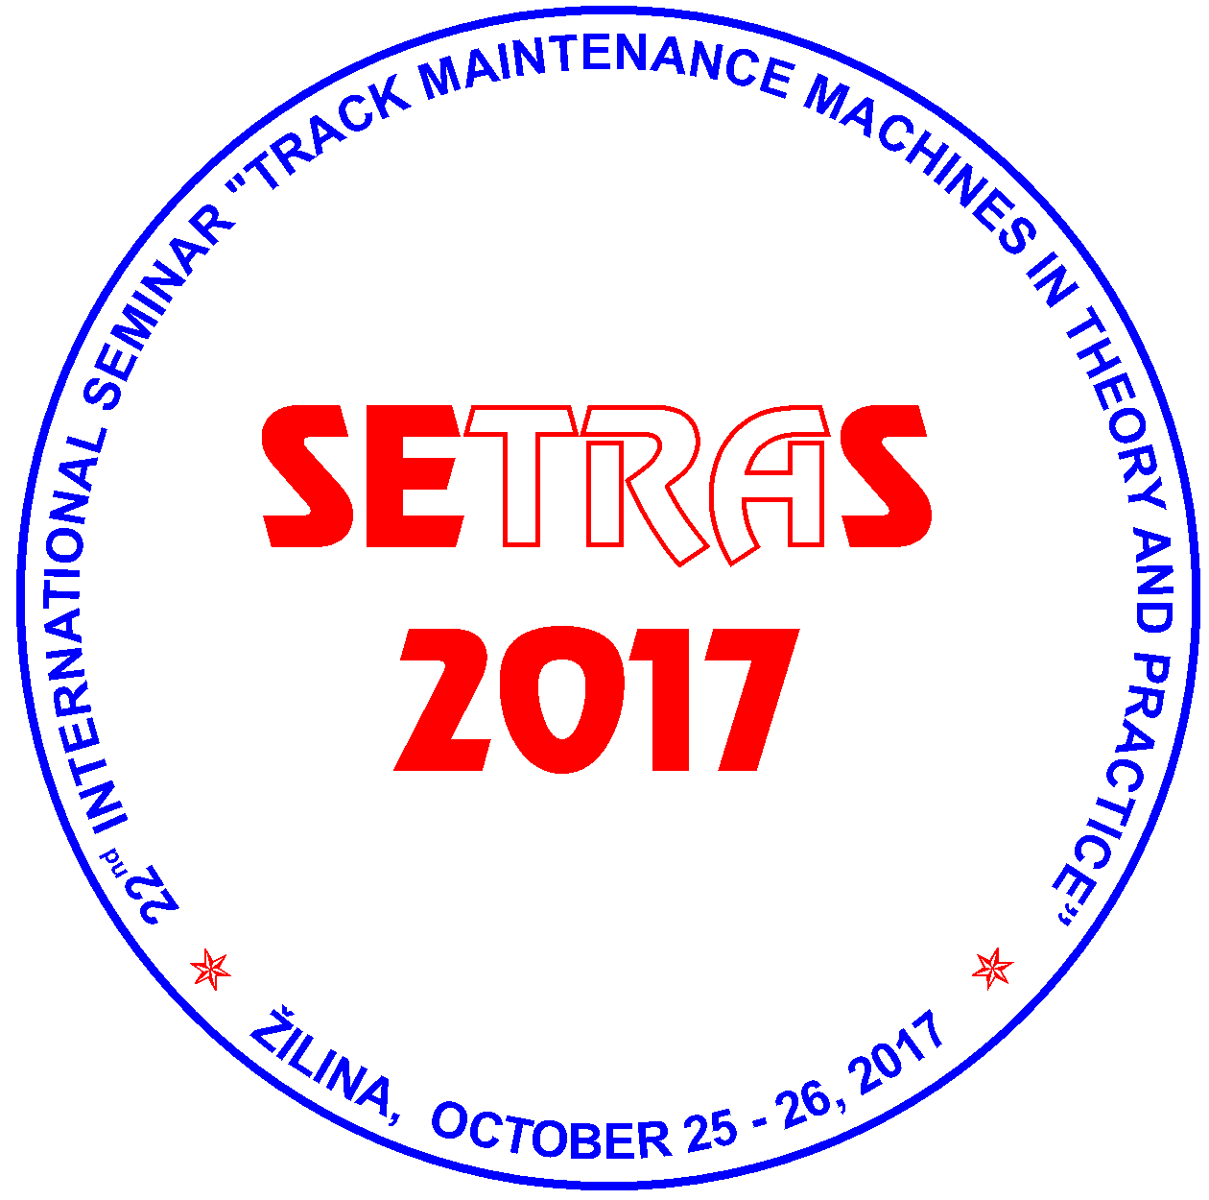

October 25 - 26, 2017
Hostels of the University of Zilina, Block G-H (GAMA Club), ZILINA, SLOVAKIA

under auspices of

Rector of the University of Zilina
Dr.h.c. prof. Ing. Tatiana COREJOVA, PhD.
and
Director General of Railways of the Slovak Republic (ZSR)
Mgr. Martin ERDÖSSY

Organizer:
Scientific and Technical Society at the University of Zilina
in co-operation with
General directorate of ZSR

PROGRAMME AND ORGANIZING COMMITTEE OF THE SEMINAR
Ing. Juraj ANTAL, Zel-Rail, Ltd., Martin, Slovakia
Ing. Peter BADO, GJW Praha, Ltd., Czech Republic
Ing. Alexander CAPLA, ZSR Bratislava, Slovakia
Ing. Miroslav DURKOVSKY, Railway Institute for Research and Development, Zilina, Slovakia
Ing. Tomas DZUGAN, Rail Servis Slovakia, Ltd. Martin, Slovakia
prof. Dr. Ing. Juraj GERLICI, Faculty of Mechanical Engineering, University of Zilina, Slovakia
Mgr. Jaroslav HANKO, ŽSR Žilina, Slovakia
Ing. Miroslav HOLLAN, Railway Infrastructure Administration, s.o., Prague., Czech Republic
doc. Ing. Milan HREBACKA, PhD, pensioner, Prague, Czech Republic
doc. Ing. Micheal LATA, PhD., Jan Perner Transport Faculty, University of Pardubice, Czech Republic
Ing. Jozef LEHOCKY, pensioner, Bratislava, Slovakia
Ing. Ladislav MATEJOV, General directorate of ZSR, Bratislava, SR
Ing. Josef NEMEC, pensioner, Praha, Czech Republic
Ing. Jiri PALASCAK, Railway Infrastructure Administration, s.o., TUDC Olomouc, Czech Republic
Ing. Janka SESTAKOVA, PhD., Faculty of Civil Engineering, University of Zilina, Slovakia.

Chairman of the Committee
prof. Ing. Daniel KALINCAK, PhD., Department of Transport and Handling Machines, Faculty of Mechanical Engineering, University of Zilina, Univerzitna 1, 010 26 ZILINA, SLOVAKIA. Tel.: (+421 41) 513 2650, tel./fax: (+421 41) 5254 440, mobil: (+421) 907 586 005,
e-mail: daniel.kalincak@fstroj.uniza.sk.

Committee secretary:
doc. Ing. Dalibor BARTA, PhD., Department of Transport and Handling Machines, Faculty of Mechanical Engineering, University of Zilina, Univerzitna 1, 010 26 ZILINA, SLOVAKIA Tel.: (+421 41) 513 2654, mobil: (+ 421) 918 663 371,
e-mail: dalibor.barta@fstroj.uniza.sk.

Seminar languages:
Slovak, Czech, English.

Seminar objectives:
The International Seminar SETRAS 2017 is organized for railway workers, urban transport and factory transport workers, manufacturers and users of track maintenance machines and its components, research and development workers, designers, universities staff and people interested in research, development, design, testing, technology, operation and maintenance of track maintenance machines.
The aim of the Seminar is to bring information to participants about state and perspectives of development in the field of track maintenance machines, small and heavy machinery for track construction and maintenance, track measurement devices and cars etc.
This year the preferred topics of the Seminar are machinery for modernisation of railway track, rail/road vehicles and machines, welding of rails, machining of rail heads and parts of railway switches, equipment for measurement, monitoring and diagnostics of railway track (track recording cars, rail profile measuring equipment, rail flaw detection systems, measuring of rail support stiffness etc.), small machinery for rail and switches maintenance, utilization of new building machines in modernisation of railway track, maintenance, refurbishment and testing of track maintenance machines and vehicles and new standards.
Further aim of the Seminar SETRAS 2017 is to offer to the companies possibility of presentation its products and services.

Deadlines:
June 19, 2017 Submission of application of the papers including summary.
June 23, 2017 Notification the participants about qualification of papers for publication.
July 21, 2017 Submission of full text papers.
From August 1, 2017 Dissemination of detailed information about program and final invitations.
September 28, 2017 Submission of application forms for participation on the Seminar.
October 25 - 26, 2017 Seminar.

If you wish to contribute to the Seminar see Call for papers and send Registration form. If you wish to advertise your firm in the Seminar please send to us filed in the form Advertising. If you wish to obtain final invitation form (it will be disseminated from beginning of August) please send to us filed in Application.
Information about place of the Seminar you can find at information map and information about urban transport at http://www.dpmz.sk/.
Further information about the Seminar will be continuously updated.

