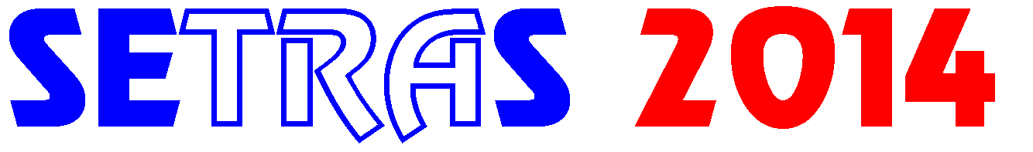

I need more detailed information about 20th International Seminar „Track maintenance machines in theory and practice -SETRAS 2014“. Please send me invitation form (it will be disseminated from August 11, 2014).

Name:

Company:

Full mailing address:

e-mail:

fax:

Please fill in this form and mail it to:
daniel.kalincak@fstroj.uniza.sk .

