16th International Seminar
„Track Maintenance Machines in Theory and Practice - SETRAS 2009“
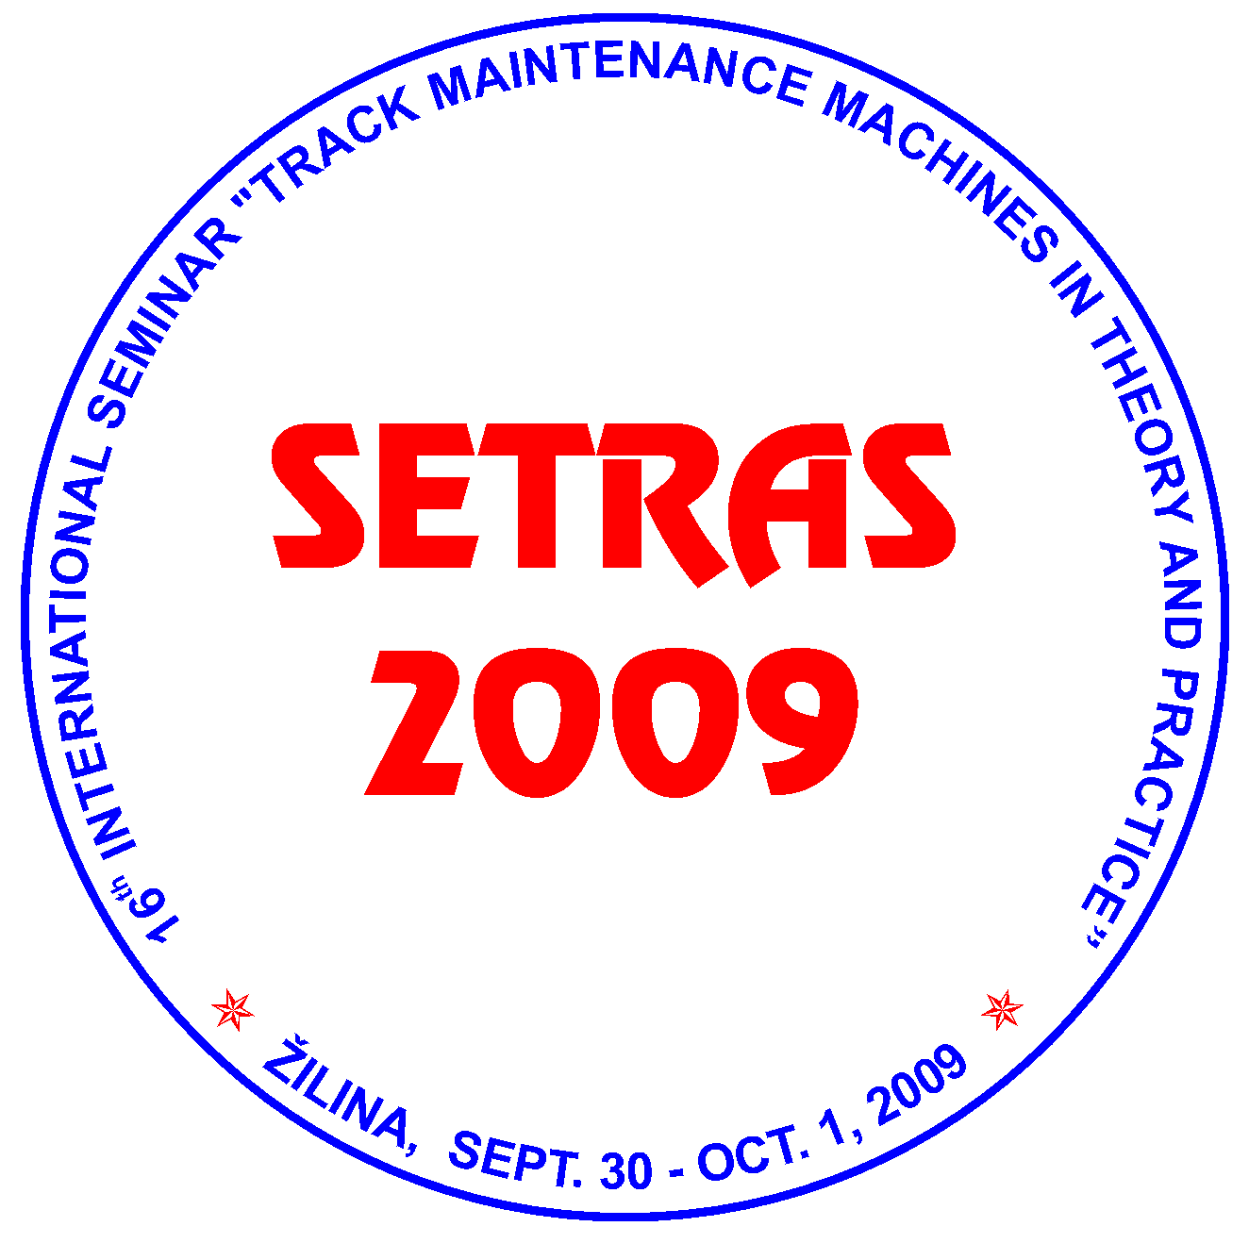

September 30 - October 1, 2009
Hostels of the University of Zilina, Block G-H (GAMA Club), ZILINA, SLOVAKIA

under auspices of

Rector of the University of Zilina
prof. Ing. Jan BUJNAK, PhD.
Director General of Railways of the Slovak Republic (ZSR)
Ing. Stefan HLINKA

Organizer:
Scientific and Technical Society at the University of Zilina
in co-operation with
General directorate of ZSR

PROGRAMME AND ORGANIZING COMMITTEE OF THE SEMINAR
Ing. Juraj ANTAL, ZEL-RAIL, Ltd., Martin, Slovakia
Ing. Daniel BOHAC, Technical Director of MTH RENOVA Ltd., Kosice, Slovakia
Ing. Miroslav DURKOVSKY, ZSR, Research and Development Institute of Railways, Zilina, Slovakia
Ing. Tomas DZUGAN, Rail Servis Slovakia, s.r.o. Martin, Slovakia
doc. Dr. Ing. Juraj GERLICI, Faculty of Mechanical Engineering, University of Zilina, Slovakia
Ing. Miloslav HRIVNA, I.M.I. Prague Ltd., Czech Republic
doc. Ing. Micheal LATA, PhD., Jan Perner Transport Faculty, University of Pardubice, Czech Republic
Ing. Jozef LEHOCKY, ZSR Bratislava, Slovakia
Ing. Jan LONDA, ZSR Zilina, Slovakia
Ing. Josef NEMEC, Endeavour s.r.o., Praha, Czech Republic
Ing. Jiri PALASCAK, SZDC, s.o., TUDC Olomouc, Czech Republic
Ing. Janka SESTAKOVA, PhD., Faculty of Civil Engineering, University of Zilina, Slovakia.

Chairman of the Committee
prof. Ing. Daniel KALINCAK, PhD., Department of Transport and Handling Machines, Faculty of Mechanical Engineering, University of Zilina, Univerzitna 1, 010 26 ZILINA, SLOVAKIA. Tel.: (+421 41) 513 2650, tel./fax: (+421 41) 5254 440, mobil: (+421 907) 586 005,
e-mail: daniel.kalincak@fstroj.uniza.sk.

Committee secretary:
Ing. Dalibor BARTA, PhD., Department of Automotive Technology, Faculty of Mechanical Engineering, University of Zilina, Univerzitna 1, 010 26 ZILINA, SLOVAKIA Tel.: (+421 41) 513 2654, mobil: (+ 421 904) 388 351,
e-mail: dalibor.barta@fstroj.uniza.sk.

Seminar languages:
Slovak, Czech, English.

Seminar objectives:
The International Seminar SETRAS 2009 is organized for railway workers, urban transport and factory transport workers, manufacturers and users of track maintenance machines and its components, research, development workers, designers, universities staff and people interested in research, development, design, testing, technology, operation and maintenance of track maintenance machines.
The aim of the Seminar is to bring information to participants about state and perspectives of development in the field of track maintenance machines, small and heavy machinery for track construction and maintenance, track measurement devices and cars vehicles etc.
This year the preferred topics of the Seminar are machinery for modernisation of railway track, rail/road vehicles, welding of rails, equipment for measurement, monitoring and diagnostics of railway track (track recording cars, rail profile measuring equipment, rail flaw detection systems, measuring of rail support stiffness etc.), small machinery for rail and switches maintenance, maintenance and refurbishment of track maintenance machines, testing of track maintenance machines and standards.
Further aim of the Seminar SETRAS 2009 is to offer to the firms possibility of presentation its products and services.

Deadlines:
May 29, 2009 Submission of application of the papers including summary.
June 8, 2009 Notification the participants about qualification of papers for publication.
July 13, 2009 Submission of full text papers.
From July 20, 2009 Dissemination of detailed information about program and final invitations.
September 4, 2009 Submission of application forms for participation on the Seminar.
Sept. 30 – Oct. 1, 2009 Seminar.

The participants of the Seminar will visit International railway exhibition ZEL-RAIL 2009 in Vrutky.

If you wish to contribute to the Seminar see Call for papers and send Registration form. If you wish to advertise your firm in the Seminar please send to us filed in the form Advertising. If you wish to obtain final invitation form (it will be disseminated from middle of July) please send to us filed in Application.
Information about place of the Seminar you can find at information map and information about urban transport at http://www.dpmz.sk/.
Further information about the Seminar will be continuously updated.

