15th International Seminar
„Track Maintenance Machines in Theory and Practice - SETRAS 2008“

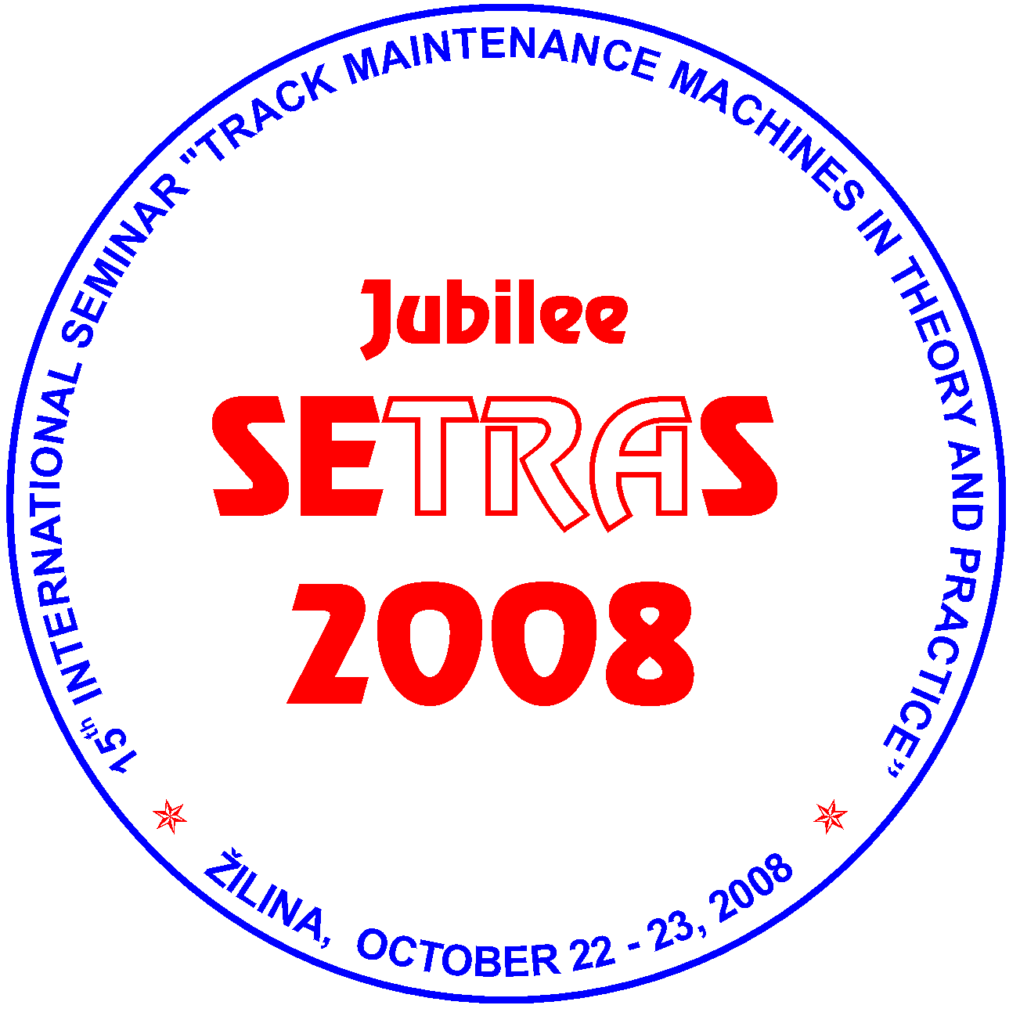
October 22 - 23, 2008
Hostels of the University of Zilina, Block G-H (GAMA Club), ZILINA, SLOVAKIA

under auspices of

Rector of the University of Zilina
prof. Ing. Ján BUJNAK, PhD.
General Director of ZSR
Ing. Stefan HLINKA

Organizer:
Scientific and Technical Society at the University of Zilina

PROGRAMME AND ORGANIZING COMMITTEE OF THE SEMINAR
Ing. Juraj ANTAL, ZEL-RAIL, Ltd., Martin, Slovakia
Ing. Daniel BOHAC, Technical Director of MTH RENOVA Ltd., Kosice, Slovakia
Ing. Miroslav DURKOVSKY, Research and Development Institute of Railways, Zilina, Slovakia
Ing. Tomas DZUGAN, Rail Servis Slovakia, s.r.o. Martin, Slovakia
doc. Dr. Ing. Juraj GERLICI, Faculty of Mechanical Engineering, University of Zilina, Slovakia
Ing. Miloslav HRIVNA, I.M.I. Prague Ltd., Czech Republic
Ing. Micheal LATA, PhD., Jan Perner Transport Faculty, University of Pardubice, Czech Republic
Ing. Jozef LEHOCKY, ZSR Bratislava, Slovakia
Ing. Jan LONDA, ZSR Zilina, Slovakia
Ing. Josef NEMEC, MTH Prague a.s., Czech Republic
Ing. Jiri PALASCAK, CD, a.s., TU CD Olomouc, Czech Republic
Ing. Jan SPANIK, PhD., Faculty of Civil Engineering, University of Zilina, Slovakia.

Chairman of the Committee
prof. Ing. Daniel KALINCAK, PhD., Department of Transport and Handling Machines, Faculty of Mechanical Engineering, University of Zilina, Univerzitna 1, 010 26 ZILINA, SLOVAKIA. Tel.: (+421 41) 513 2650, tel./fax: (+421 41) 5254 440, mobil: (+421 907) 586 005,
e-mail: daniel.kalincak@fstroj.uniza.sk.

Committee secretary:
Ing. Dalibor BARTA, PhD., Department of Transport and Handling Machines, Faculty of Mechanical Engineering, University of Zilina, Univerzitna 1, 010 26 ZILINA, SLOVAKIA Tel.: (+421 41) 513 2654, mobil: (+ 421 904) 388 351,
e-mail: dalibor.barta@fstroj.uniza.sk.

Seminar languages:
Slovak, Czech, English.

Seminar objectives:
The International Seminar SETRAS 2008 is organized for railway workers, urban transport and factory transport workers, manufacturers and users of track maintenance machines and its components, research, development workers, designers, universities staff and people interested in research, development, design, testing, technology, operation and maintenance of track maintenance machines.
The aim of the Seminar is to bring information to participants about state and perspectives of development in the field of track maintenance machines, small and heavy machinery for track construction and maintenance, track measurement devices and cars vehicles etc.
This year the preferred topics of the Seminar are machinery for modernisation of railway track, rail/road vehicles, welding of rails, equipment for measurement, monitoring and diagnostics of railway track (track recording cars, rail profile measuring equipment, rail flaw detection systems, measuring of rail support stiffness etc.), small machinery for rail and switches maintenance, maintenace and refurbishment of track maintenace machines and testing of track maintenance machines.
Further aim of the Seminar SETRAS 2008 is to offer to the firms possibility of presentation its products and services.

Deadlines:
May 30, 2008 Sending of application of the papers including summary,
June 6, 2008 Notifying the participants about qualification of papers for publication,
July 25, 2008 Submitting of full text papers,
From July 15, 2008 Submitting detailed information about program and final invitations,
September 26, 2008 Sending application forms for participation on the Seminar,
October 22 - 23, 2008 Seminar.

If you wish to contribute to the Seminar see Call for papers and send Registration form. If you wish to advertise your firm in the Seminar please send to us filed in the form Advertising. If you wish to obtain final invitation form (it will be printed out on July) please send to us filed in Application.
Information about place of the Seminar you can find at information map and information about urban transport at http://www.dpmz.sk/.
Further information about the Seminar will be continuously updated.

