12th International Seminar
„Track Maintenance Machines in Theory and Practice - SETRAS 2004“

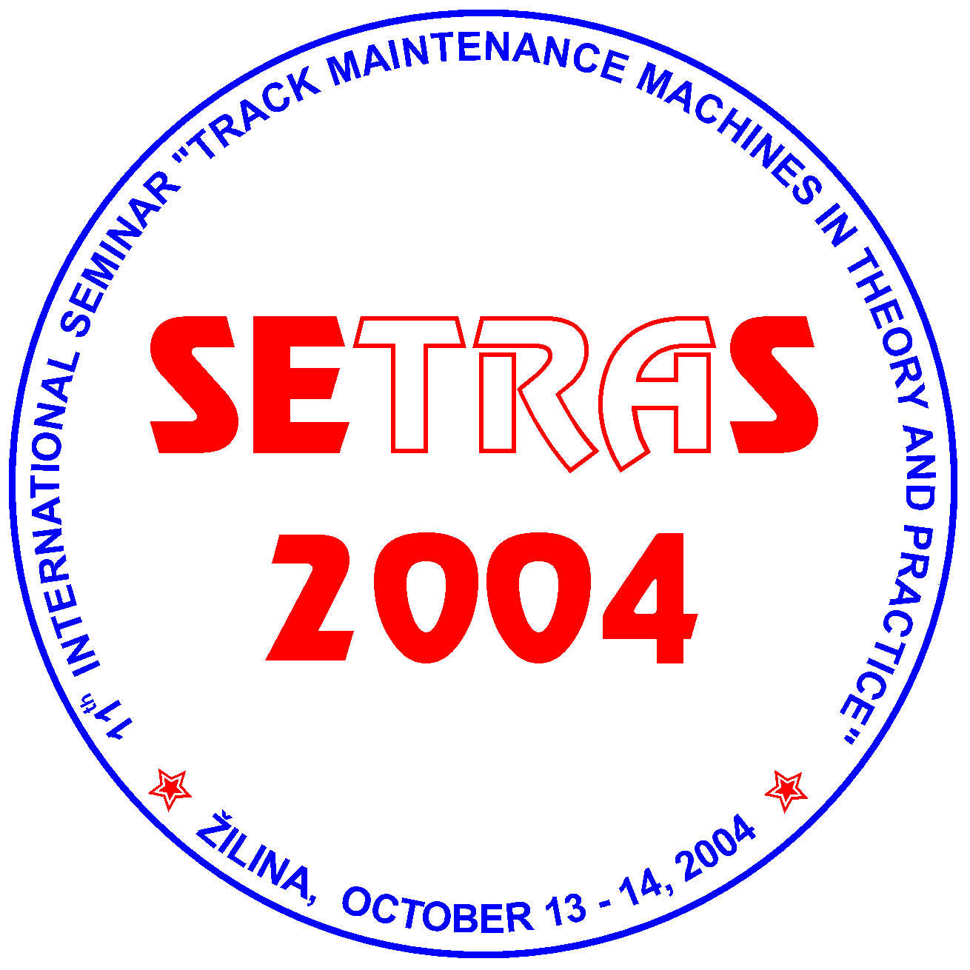
October 13 - 14, 2004
Hostels of the University of Zilina, Block G-H (GAMA Club), ZILINA, SLOVAKIA

under auspices of
General Director of ZSR
Ing. Roman VESELKA
and
Rector of the University of Zilina
Prof. Ing. Ján BUJŇÁK, PhD.

Organizer:
Scientific and Technical Society at the University of Zilina

PROGRAMME AND ORGANIZING COMMITTEE OF THE SEMINAR
Ing. Zoltan ADAM, Director of Research and Development Institute of Railways, Zilina,
Ing. Juraj ANTAL, COMPEL-RAIL, a.s., Martin,
Ing. Daniel BOHAC, Technical Director of MTH RENOVA Ltd., Kosice,
Ing. Tomas DZUGAN, COMPEL, a.s. Martin,
Dr.Ing. Juraj GERLICI, Faculty of Mechanical Engineering, University of Zilina,
Ing. Miloslav HRIVNA, I.M.I. Prague Ltd.,
Ing. Vaclav JELINEK, CD - TÚDC Olomouc,
Ing. Jozef LEHOCKY, ZSR, Bratislava,
Ing. Jan LONDA, ZSR, Zilina,
Ing. Stefan MAYERBERGER, CD - Railway Research Institute Prague,
Ing. Josef NEMEC, Technical Director of MTH Prague a.s.,
Ing. Jan SPANIK, PhD., Faculty of Civil Engineering, University of Zilina.

Chairman of the Committee
Doc. Ing. Daniel KALINCAK, PhD., Department of Railway Vehicles, Engines and Lifting Equipment, Faculty of Mechanical Engineering, University of Zilina, ZU Zilina, Velky diel, 010 26 ZILINA, SLOVAKIA. Tel.: (+421 41) 513 2650, tel./fax: (+421 41) 5254 440, mobil: (+421 907) 586 005, e-mail: daniel_kalincak@kkvmz.utc.sk.

Committee secretary:
Ing. Dalibor BARTA,. Department of Railway Vehicles, Engines and Lifting Equipment, Faculty of Mechanical Engineering, University of Zilina, Velky diel 20, 010 26 ZILINA, SLOVAKIA Tel.: (+421 41) 513 2668, mobil: (+ 421 904) 388 351, e-mail: dalibor@kkvmz.utc.sk.

Seminar languages:
Slovak, Czech, English.

Seminar objectives:
The International Seminar SETRAS 2004 is organized for railway workers, urban transport and factory transport workers, manufacturers and users of track maintenance machines and its components, research, development workers, designers, universities staff and people interested in research, development, design, testing, technology, operation and maintenance of track maintenance machines.
The aim of the Seminar is to bring information to participants about state and perspectives of development in the field of track maintenance machines, small and heavy machinery for track construction and maintenance, track measurement devices and cars etc.
This year the preferred topics of the Seminar are machinery for modernised railway track, rail/road vehicles, equipment for diagnostics of railway track (track recording cars, rail profile measuring equipment, rail flaw detection systems, measuring of rail support stiffness etc.) and measuring and guiding systems for track maintenance machines.
Further aim of the Seminar SETRAS 2004 is to offer to the firms possibility of presentation its products and services.

Deadlines:
May 7, 2004 Sending of application of the papers including summary,
May 31, 2004 Notifying the participants about qualification of papers for publication,
July 9, 2004 Submitting of full text papers,
August 10, 2004 Submitting detailed information about program and final invitations,
September 13, 2004 Sending application forms for participation on the Seminar,
October 13 - 14, 2004 Seminar.

If you wish to contribute to the Seminar see Call for papers and send Registration form. If you wish to advertise your firm in the Seminar please send to us filed in the form Advertising. If you wish to obtain final invitation form (it will be printed out on July) please send to us filed in Application.
Information about place of the Seminar you can find at information map and information about urban transport at http://www.dpmz.sk/.
Further information about the Seminar will be continuously updated.

