22th International Conference
“CURRENT PROBLEMS IN RAIL VEHICLES - PRORAIL 2015”
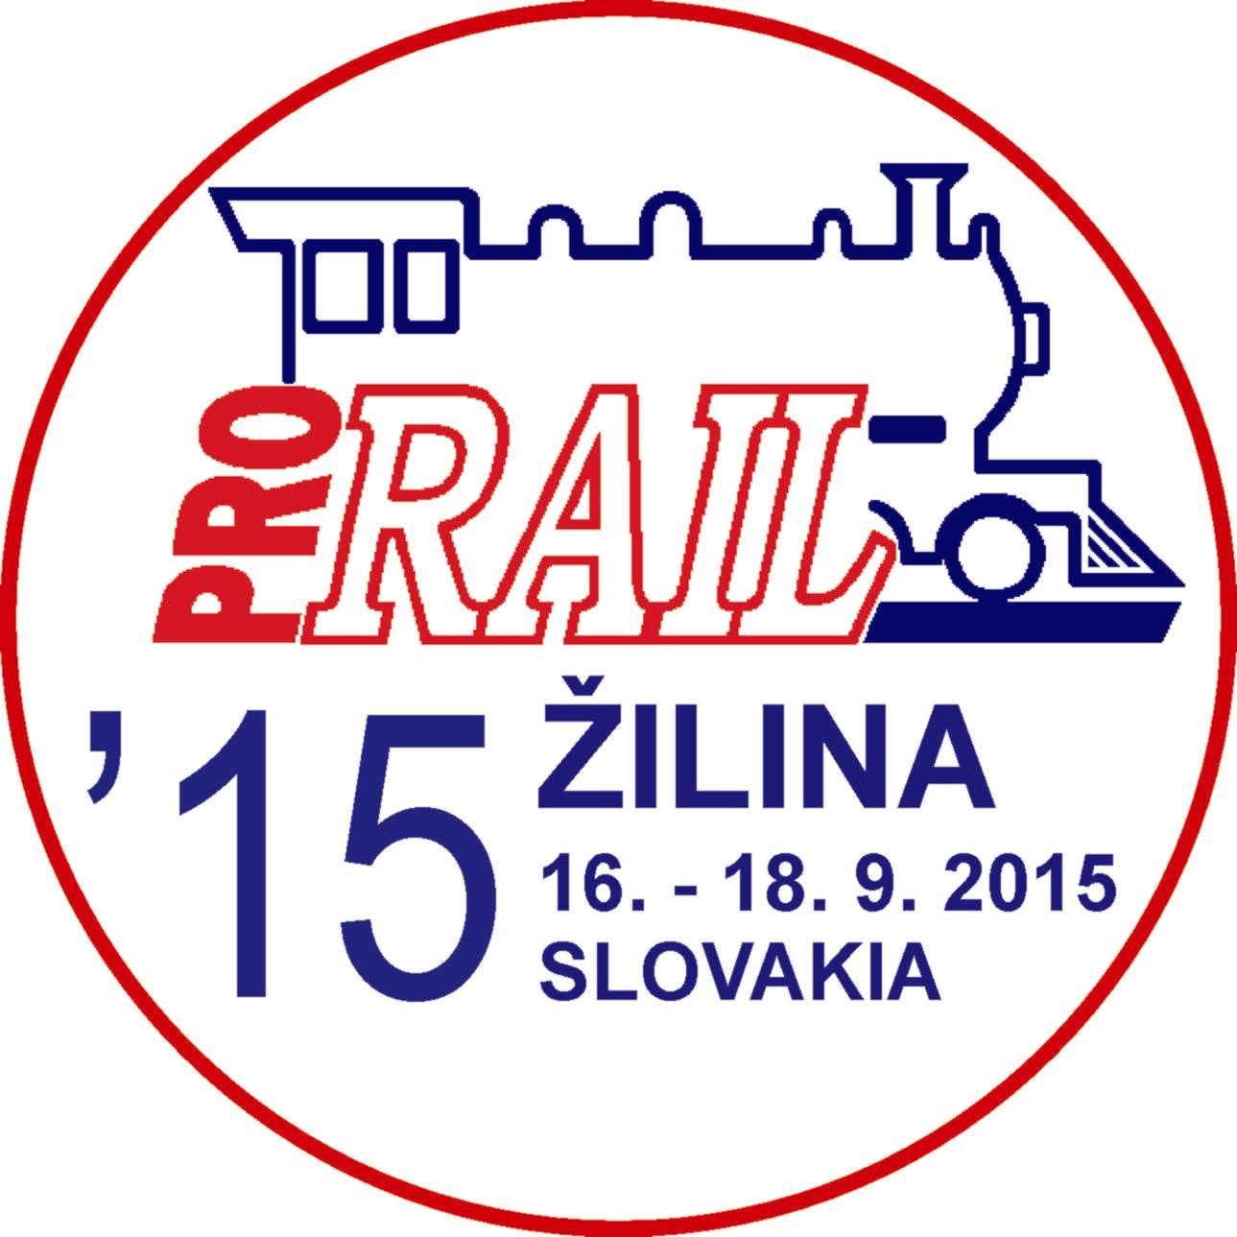

UNIVERSITY OF ŽILINA
September 16 - 18, 2015, ŽILINA, SLOVAKIA

under the auspices of
Minister of Transport, Construction and Regional Development
of the Slovak Republic
Ing. Ján POČIATEK
Rector of the University of Žilina
Dr.h.c. Prof. Ing. Tatiana ČOREJOVÁ, PhD.,
Chairman of the Board of Directors and Director General
of the Railway Company Slovensko, j.s.c.
Ing. Pavol GÁBOR
Chairman of the Board of Directors and Director General
of the Railway Company Cargo Slovakia, j.s.c.
Ing. Vladimír ĽUPTÁK
Organisers:
Scientific and Technical Society at the University of Zilina
Faculty of Mechanical Engineering of the University of Zilina
The Jan Perner Transport Faculty of the University of Pardubice
Scientific Committee:
Chairman:
Prof. Ing. Daniel Kalinčák, Ph.D., FME University of Zilina, SK
Members:
Ing. Jozef Blcha, ASTRA Rail Project s.r.o., Poprad, SK
Prof. Ing. Bohumil Culek, Ph.D., JPTF University of Pardubice, CZ
Assoc. Prof. Ing. Jan Famfulík, Ph.D., IT VSB - TU Ostrava, CZ
Prof. Dr. Ing. Juraj Gerlici, FME University of Zilina, SK
Assoc. Prof. Ing. Juraj Grenčík, Ph.D., FME University of Zilina, SK
Prof. Antonio Gugliotta, Politecnico di Torino, IT
Prof. Dr.-Ing. Markus Hecht, TU Berlin, D
Assoc. Prof. Ing. Petr Heller, Ph.D., University of West Bohemia, Pilsen, CZ
Prof. Andzej Chudzikiewicz, Ph.D., D.Sc., TU Warsaw, PL
Ing. Jan Kalivoda, Ph.D., FME Czech Technical University in Prague, CZ
Ing. Petr Kaván, Ph.D., VUZ - Railway Research Institute, a.s., Prague, CZ
Assoc. Prof. Ing. Josef Kolář, Ph.D., FME Czech Technical University in Prague, CZ
Assoc. Prof. Ing. Tomáš Lack, Ph.D., FME University of Zilina, SK
Assoc. Prof. Ing. Michael Lata, Ph.D., JPTF Univer. of Pardubice, CZ
Ing. Miloslav Lužák, Railway Company Cargo Slovakia, a.s., Bratislava, SK
Ing. Zdeněk Malkovský, VUKV, a.s., Prague, CZ
Ing. Matěj Pácha, PhD., EF University of Zilina, SK
Ing. Marián Moravčík, PhD., Tatravagonka a.s., Poprad, SK
Prof. Marek Pawełczyk, Ph.D., D.Sc., TU Kielce, PL
Ing. Jozef Peško, Railway Company Slovensko, a.s., Bratislava, SK
Prof. Paweł Piec, Ph.D., D.Sc., Cracow University ofTechnology, PL
Prof. Ing. Oldřich Polách, Ph.D., Bombardier Transportation (Switzerland), AG, Winterthur, CH
Ing. Tibor Polyák, ZSR Railway Institute of Research and Development, Bratislava, SK
Ing. Jiří Segeťa, SKODA VAGONKA a.s., Ostrava, CZ
Prof. Marek Sitarz, Ph.D., D.Sc., University of Dąbrowa Górnicza, PL
Assoc. Prof. Ing. Josef Soukup, Ph.D., Jan Evangelista Purkyne University in Usti nad Labem, CZ
prof. Dr. Dušan Stamenković, FME University of Niš, SRB
Ing. Jiří Štěpánek, CZ LOKO, a.s., Česká Třebová, CZ
Ing. Jan Zapletal, SKODA TRANSPORTATION a.s., Pilsen, CZ
Assoc. prof. Ing. Jaromír Zelenka, Ph.D., JPTF University of Pardubice, CZ
Prof. Dr. Sc. Istvan Zobory, FTE BME Budapest, HU
Prof. Ing. Peter Zvolenský, Ph.D., FME University of Zilina, SK

Organising Committee:
Chairman:
Assoc. prof. Ing. Dalibor Barta, Ph.D., FME University of Zilina, SK
Tel.: +421 (0)41 513 2654, Mobil: +421 (0)918 663 371,
e-mail: dalibor.barta@fstroj.uniza.sk

Conference languages:
Slovak, Czech, English

Objectives:
The aim of the Conference is to present new achievements in the research, development, design, operation and maintenance of rail vehicles.

The main Conference topics are:
- the new concepts of transport systems with regard to rail vehicles,
- new legislation and standards (Directives of EC, TSI, EN, UIC Codes, etc.) regarding of the rail vehicle,
♣ design of rail vehicles and their main systems (e.g. engines, power transmission, control systems, braking systems, auxiliaries, equipment for passenger compartments, etc.),
♣ technical means of combined transport,
- theoretical problems in the development and design of rail vehicles,
- contact wheel/rail,
♣ safety of rail vehicles,
♣ experimental methods and testing of rail vehicles,
♣ materials and technologies in construction of rail vehicles,
♣ systems and rail vehicles for mass urban transport,
- information systems of rail vehicles,
- operation of rail vehicles,
♣ diagnostics, maintenance and servicing of rail vehicles,
- environmental aspects of rail vehicles,
- road/rail vehicles,
♣ special vehicles (rail cranes, trolley line inspection vehicles, track maintenance machines, track recordings cars etc.).

The programme and organizing committee looks forward to your papers in the areas mentioned above. The papers will be published in the Proceedings of the Conference. Please, mark your interest in the enclosed participation form (REPLY15.DOC), which should be posted not later than May 25, 2015 to our address. You will get detailed information about the Conference in the invitation form at the end of July.
We offer to firms a possibility of advertising on this Conference. If you are interesting in advertising, please mark it in Reply Form and we will send you detailed information.

Preliminary instructions for the authors of papers:
♠ The reply card has to contain authors' and co-authors´ names, title of the paper and abstract of the paper.
♠ The decision of the Scientific Committee regarding the acceptance of your paper, together with detailed instructions about formal layout of paper will be sent to you by May 29, 2015.
♠ We ask you to submit your paper by e-mail or CD written in MS Word and one printed copy of the paper not later than June 29, 2015.
♠ The programme of the Conference and the invitation form with detailed information about the Conference, room and boarding etc. will be sent by the end of July, 2015.
♠ Please, send the filled in Reply Card by e-mail or to the following address not later than May 25, 2015.
Prof. Ing. Daniel KALINČÁK, PhD.
VTS pri ŽU
Univerzitná 1, 010 26 ŽILINA, SLOVAKIA
Tel.: +421 (0)41 513 2650, Tel./fax: +421 (0)41 5254 440, Mobil: +421 (0)907 586 005
e-mail: daniel.kalincak@fstroj.uniza.sk

