20th International Conference
“CURRENT PROBLEMS IN RAIL VEHICLES - PRORAIL 2011”
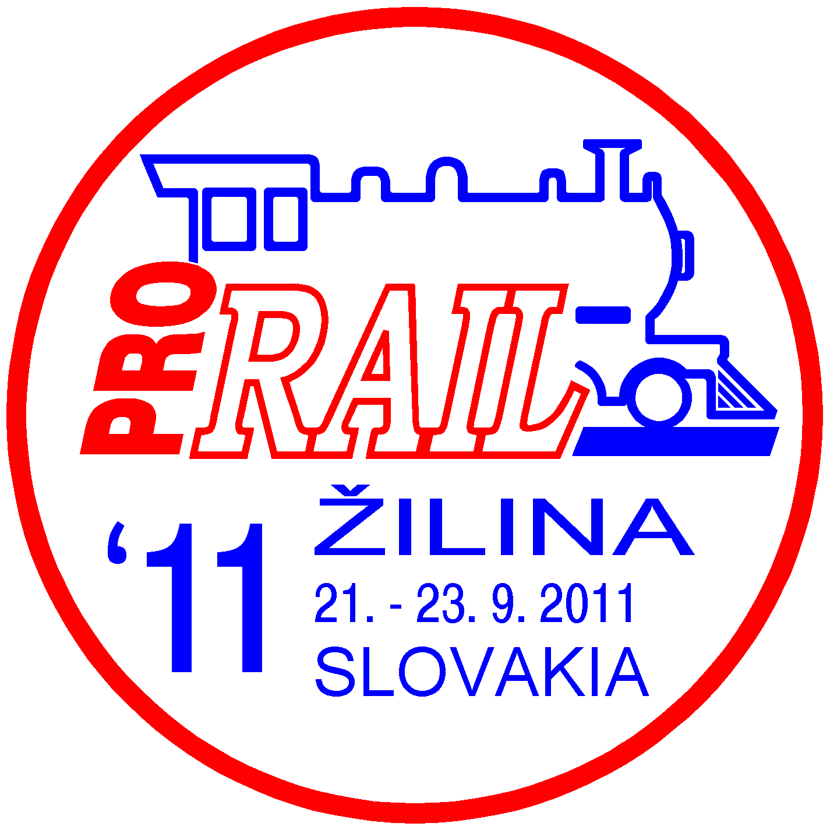

UNIVERSITY OF ZILINA
September 21 - 23, 2011, ZILINA, SLOVAKIA

Organisers:
Scientific and Technical Society at the University of Zilina
Faculty of Mechanical Engineering of the University of Zilina
The Jan Perner Transport Faculty of the University of Pardubice

Scientific Committee:
Chairmans:
Prof. Ing. Bohumil Culek, Ph.D., Jan Perner Transport Faculty, University of Pardubice, CZ
Prof. Ing. Daniel Kalincak, Ph.D., Faculty of Mechanical Engineering, University of Zilina, SK
Prof. Ing. Peter Zvolensky, Ph.D., Faculty of Mechanical Engineering, University of Zilina, SK

Organising Committee:
Chairman:
Ing. Dalibor Barta, Ph.D., FME University of Zilina, SK
Tel.: +421 (0)41 513 2654, Fax. +421 (0)41 5253 016, Mobil: +421 (0)904 388 351,
e-mail: dalibor.barta@fstroj.uniza.sk

Conference languages:
Slovak, Czech, English

Objectives:
The aim of the Conference is to present new achievements in the research, development, design, operation and maintenance of rail vehicles.


The Conference will be held under the framework of the week's activities in the railway area named RAILINFORM 2011..
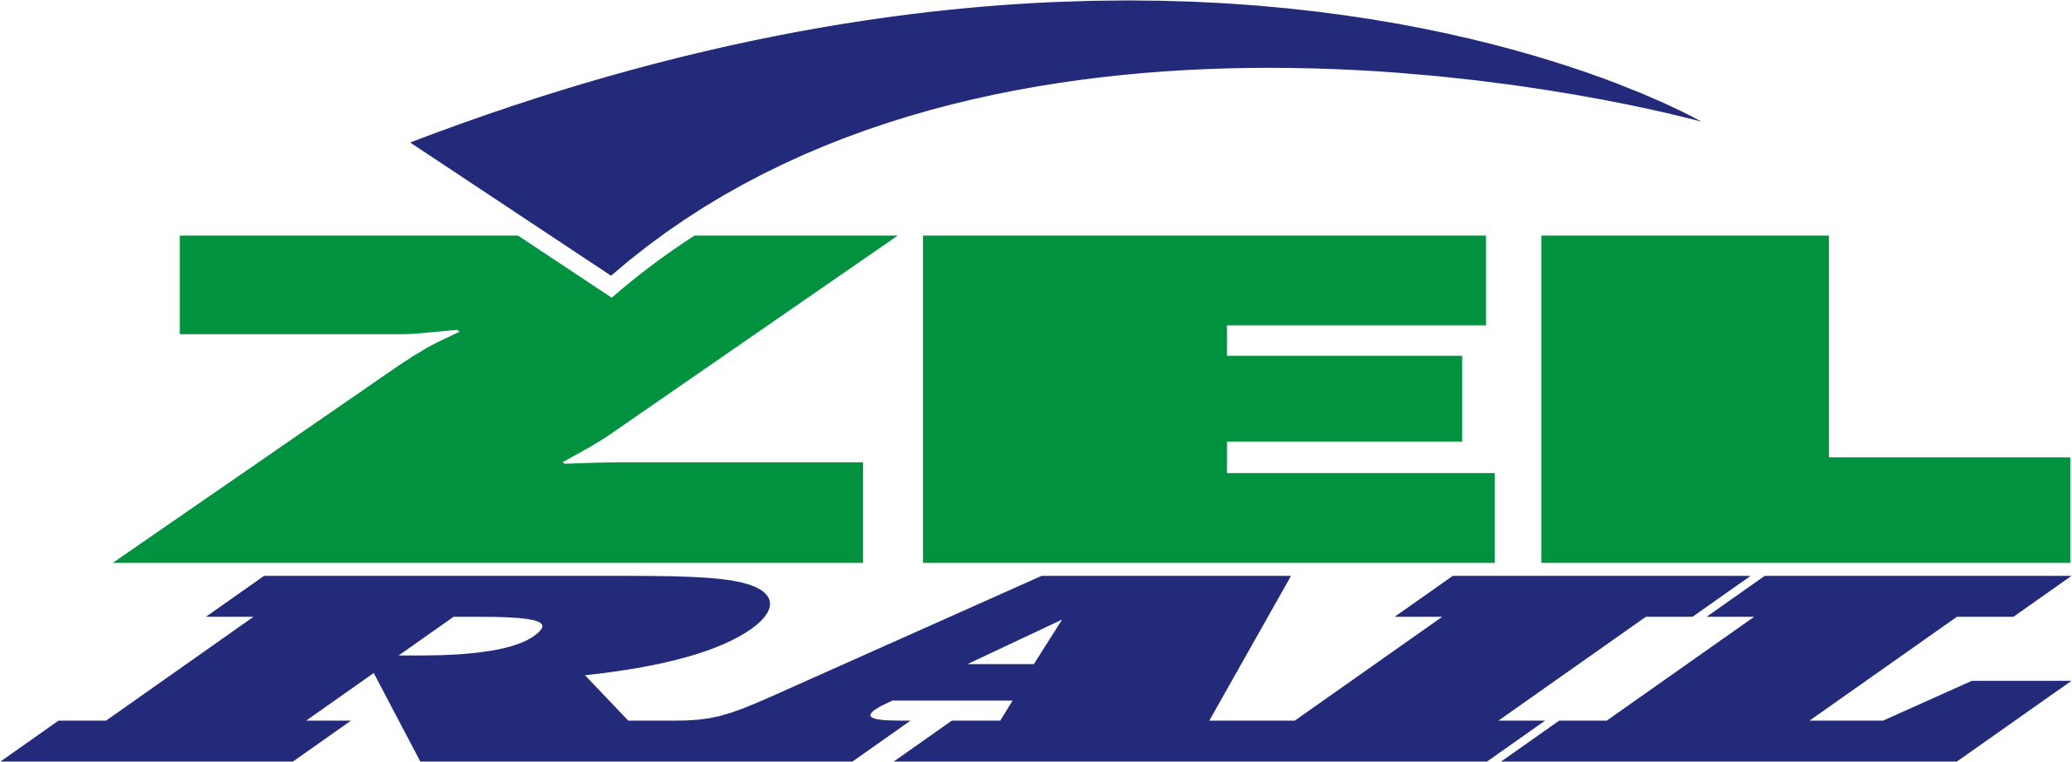
In the programme of the Conference will be included also visit of the exhibition ZEL-RAIL 2011.

The main Conference topics are:
- the new concepts of transport systems with regard to rail vehicles,
- new legislation and standards (Directives of EC, TSI, EN, UIC Codes, etc.) regarding of the rail vehicle,
♣ design of rail vehicles and their main systems (e.g. engines, power transmission, control systems, braking systems, auxiliaries, equipment for passenger compartments, etc.),
♣ technical means of combined transport,
♣ theoretical problems in the development and design of rail vehicles,
♣ safety of rail vehicles,
♣ experimental methods and testing of rail vehicles,
♣ materials and technologies in construction of rail vehicles,
♣ systems and rail vehicles for mass urban transport,
- information systems of rail vehicles,
- operation of rail vehicles,
♣ diagnostics, maintenance and servicing of rail vehicles,
- environmental aspects of rail vehicles,
- road/rail vehicles,
♣ special vehicles (rail cranes, trolley line inspection vehicles, track maintenance machines, track recordings cars etc.).

The programme and organizing committee looks forward to your papers in the areas mentioned above. The papers will be published in the Proceedings of the Conference. Please, mark your interest in the enclosed participation form (REPLY11.DOC), which should be posted not later than April 21, 2011 to our address. You will get detailed information about the Conference in the invitation form at the end of July.
We offer to firms a possibility of advertising on this Conference. If you are interesting in advertising, please mark it in Reply Form and we will send you detailed information.

Preliminary instructions for the authors of papers:
♠ The reply card has to contain authors' and co-authors´ names, title of the paper and abstract of the paper.
♠ The decision of the Scientific Committee regarding the acceptance of your paper, together with detailed instructions about formal layout of paper will be sent to you by May 10, 2011.
♠ We ask you to submit your paper by e-mail or CD written in MS Word and one printed copy of the paper not later than June 24, 2011.
♠ The programme of the Conference and the invitation form with detailed information about the Conference, room and boarding etc. will be sent by the end of July, 2011.
♠ Please, send the filled in Reply Card by e-mail or to the following address not later than April 21, 2011.
Prof. Ing. Daniel KALINČÁK, PhD.
VTS pri ŽU
Univerzitná 1, 010 26 ŽILINA, SLOVAKIA
Tel.: +421 (0)41 513 2650, Tel./fax: +421 (0)41 5254 440, Mobil: +421 (0)907 586 005
e-mail: daniel.kalincak@fstroj.uniza.sk

