
16th INTERNATIONAL CONFERENCE
„CURRENT PROBLEMS IN RAIL VEHICLES - PRORAIL 2003“
October 8. – 10, 2003, Žilina, Slovakia
GUIDELINES FOR WRITING PAPERS
NÁVOD NA PÍSANIE PRÍSPEVKU
Daniel KALINČÁK, Dalibor BARTA*)
1 INTRODUCTION
All the authors are asked to prepare their papers in compliance with the following guidelines. The papers should be written in English. The following format should be kept: a page size A4 (21 cm x 29,7 cm), spacing 1 (single), margins for the whole paper: 4,0 cm - left margin, 4,0 cm - right margin, 4,4 cm - top margin, 4,4 cm - bottom margin. (The Proceedings of the Conference will be printed in format B5 (17,6 cm x 25,0 cm). The top margin on the first page should be 8,5 cm for the heading of the Conference. If you will use of attached template, the heading of the Conference is included, so you do not left place for it on the first page of the paper.
The English title of the paper should be written in Arial 11 bold, the Slovak title (translation to Slovak will be delivered to authors by us) should be written in Arial 11 bold slanted and both of them in capital letters. The authors´ names should be written under the title in Arial 10 bold (family name in capital letters). Title and names should be centred to the middle of the page. The authors´ addresses and their brief professional characteristics should be written as footnote in Arial 9. The author’s names itself in footnote should be written in bold and underlined.
When writing titles of the paper and authors´ names, paragraph spacing 6 pt before and 6 pt after should be used.
The number of pages, including figures, tables, references and summaries should not exceed 10 pages. The pages should be numbered in the right bottom corner of the reverse side of the pages by soft pencil. If you will use of attached template, the heading of the pages and its numbering is included, so you need not write numbers of pages on reverse side.

The authors´ names are followed by the introduction and text of the paper. All text of the paper to be written in Arial 9. Titles of the chapters should be written in Arial 9 bold in capital letters (titles of subchapters Arial 9 bold in minuscule letters).
2 TEXT OF PAPER
The authors are advised to use a text editor MS Word for Windows, WordPerfect or a similar programs.
When writing titles of chapters paragraph spacing 12 pt before and 6 pt after should be used. When writing titles of subchapters paragraph spacing 6 pt before and 6 pt after should be used.
Spacing of paragraphs in text should be 2 pt before and 2 pt after the paragraph.
2.1 Mathematic formulae
The formula used in the paper should be written in Arial 9 bold slanted and numbered. The number of the formula should be written in brackets at right margin.
E = m.c² (1)
2.2 Figures, tables, graphs
Figures, tables and graphs should be included in the text and numbered in Arabic numerals. Under the figure there should be written its title in Arial 9 slanted aligned to the centre of the figure (see Fig.1).
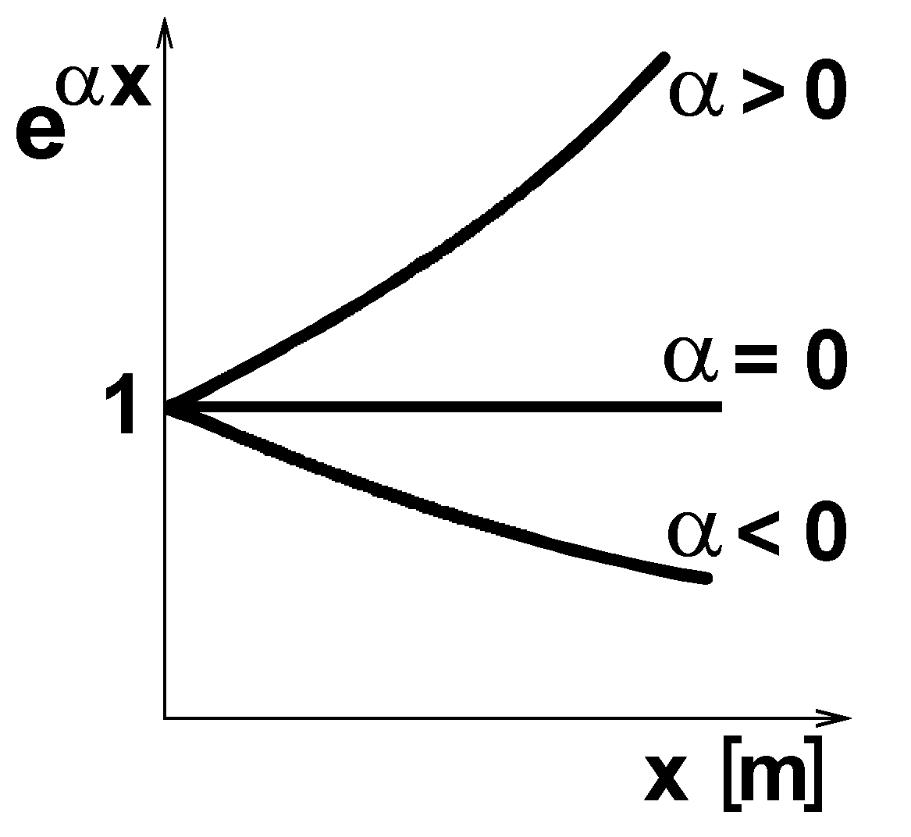
Fig. 1 Text related to the figure
Tittles of graphs should be written in similar way as figures but with their own sequence of numerals.
Tables should be numbered in similar way, but with their own sequence of numerals. Title of table should be written over the table in Arial 9 slanted (see example TABLE 1) aligned to the centre of the table.
When saving the paper on diskette or sending by e-mail it is appropriate to link figures with text and save them separately.

TABLE 1 Text related to the table
Velocity [km/h] | Ride index vertical | Ride index horizontal
80 | 2,32 | 2,41
100 | 2,38 | 2,42
120 | 2,41 | 2,44
3 CONCLUSION
After conclusion follows references and summary in English (Arial 9 slanted). Summary in Slovak will be inserted in text by the organising committee. Therefore on the last page of paper a space of minimum 7 cm (+ 4,4 cm for margin) must be left empty.
The authors are asked to send two copies of their papers to the contact address not later than July 7, 2003. The authors are asked to send their papers (complete text including pictures) also in electronical form by e-mail (preferentially) or on diskette or on CD.
References
[1] Slaninka, J.: Hnacie vozidlá v železničnej praxii. ALFA Bratislava 1988. [2] Eck, B.: Technische Strömungslehre, Springer Verlag Berlin, Heidelberg, New York 1981. ...
♠♠♠
Summary
The summary, which should be at the end of paper, is to be written in English in Arial 9 slanted. Summary has to be in extent sufficient for understanding the meaning of the paper.
Resumé
It will be written in Slovak and inserted by organising committee. Here leave out a minimum 7 ( +4,4 margin) cm space.

*) Doc. Ing. Daniel KALINČÁK, PhD., Department of railway vehicles, engines and lifting equipment, Faculty of Mechanical Engineering, University of Žilina, Moyzesova 20, 010 26 ŽILINA, Slovakia. Tel.: (++421 41) 513-2650, Tel./fax: (++421 41 ) 5254 440, e-mail: daniel_kalincak@kkvmz.utc.sk. 56 years. Head of the Department, he is concerned with theory of rail vehicles and track maintenance machines. Ing. Dalibor BARTA, Tel. (++421 41) 513-2669, e-mail: dalibor@kkvmz.utc.sk. 32 years, he is concerned with interaction of rail vehicles and track. (a co-author´s address should be given only when different from the first author´s)

